TCP port of the Initial access machine which hosts monitoring software

8091

Completed

Web directory with which reveals sensitive information (Example : Case sensitive)

assets

Completed

Base64 hash of db-pass credentials

REJfUEBzc3cwcmQh

Completed

Working password of “HotHost” web application

Very3stroungPassword

Completed

Web application route which reveals the system files (Example : /route, do not include forward slash)

pug

Completed

What is the “secretToken” string which is present in the above route (Example : Case sensitive)

Monitor the system files

Completed

Payload through which hosts system “passwd” file can be read (Example : file:///location/passwd)

file:///hostfs/etc/passwd

Completed

Discovered credentials of “app-admin”

@dmin@123

Completed

Commands that “app-admin” can run on the initial access machine (Example : Mention exact path like /etc/passwd)

/usr/bin/vi

Completed

IP Address discovered from the log file

10.10.10.20

Completed

The service version name running on web port on the discovered ip address (Enter the version only : 3.2.1)

2.4.58

Completed

Complete URL which reveals sync_user credentials (Example : http://IP/location/file.txt, Case sensitive))

http://10.10.10.20/elfinder/files/AD_Resources.txt

Completed

What is the password of the sync_user

Summer@2025

Completed

What is the Domain Controller IP Address

10.10.10.100

Completed

What is the krbtgt account NT hash of the domain

36405f88da713c31bbff52e57aea1f86

Completed

Directory location in the domain controller which contains the sensitive xml file (Example : C:\Windows\System32)

C:\Users\Administrator\Desktop

Completed

What is the base salary of the user with the position “Director of Engineering”

189500

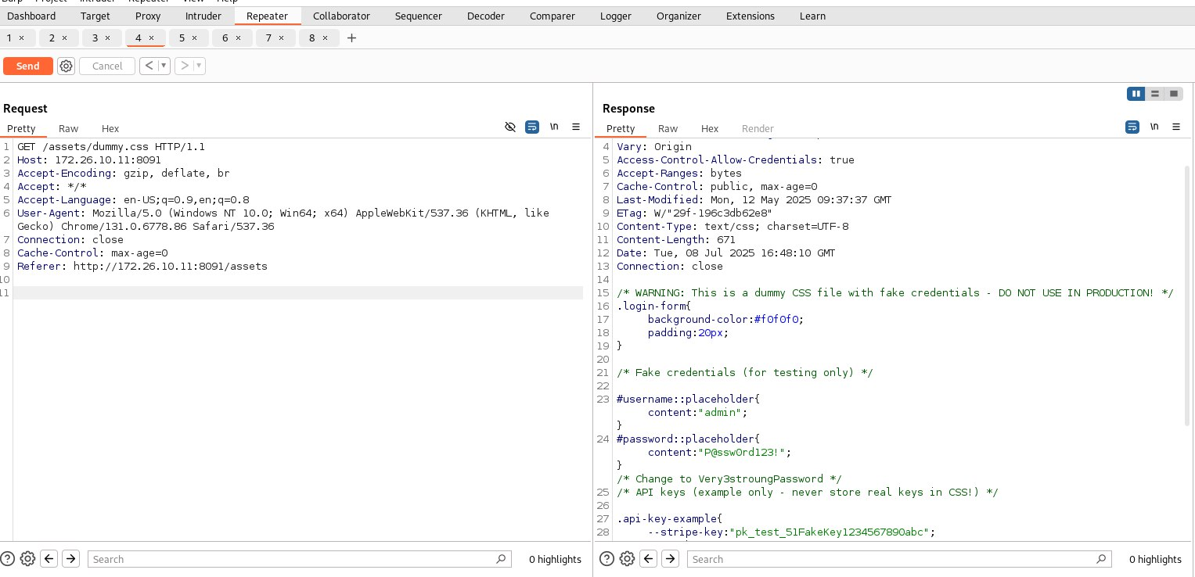

I already login as admin using the password Very3stroungPassword

